GIT AND GIT HUB
- Install git.
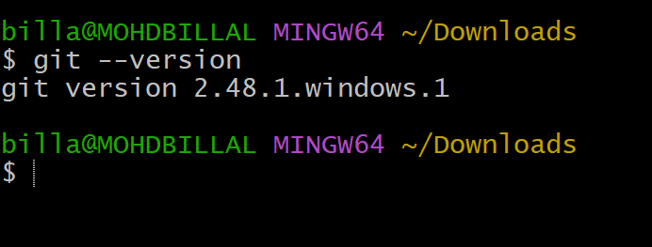

- Create a repo in github with README.md and .ignore file.
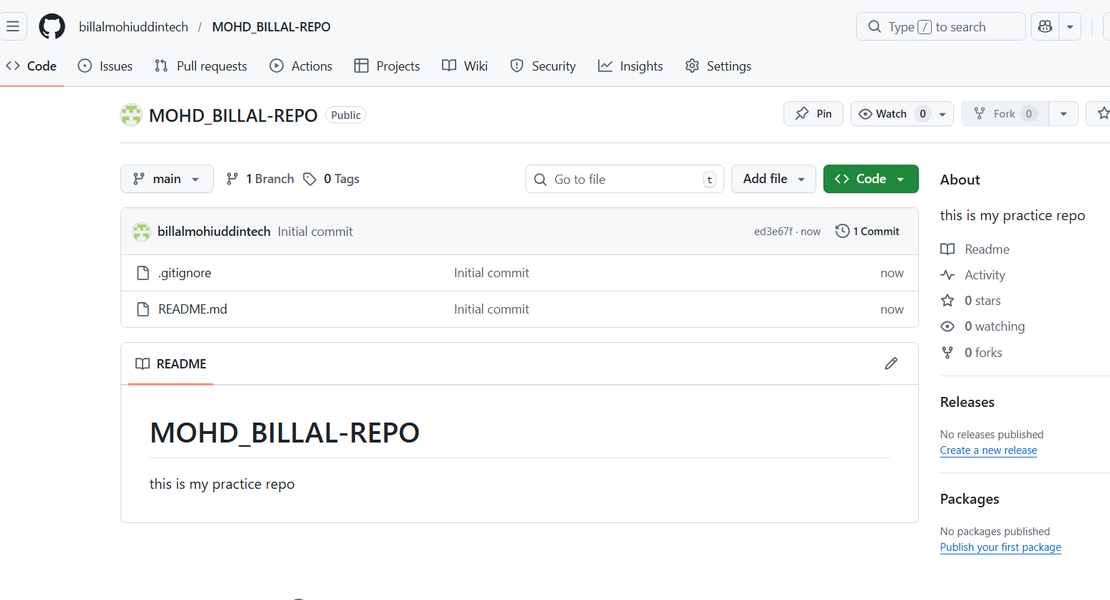

- Clone the created repo to local.
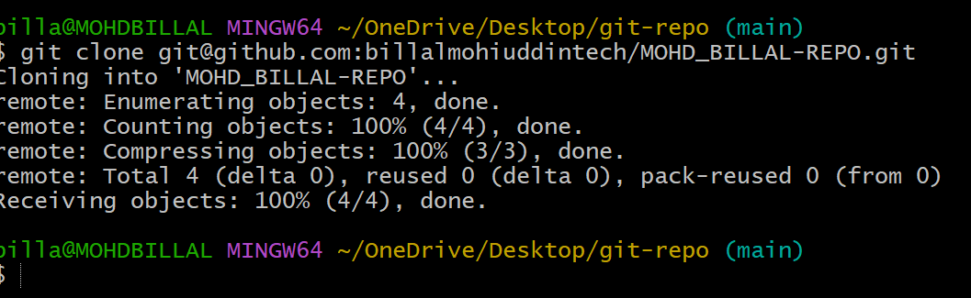
- Create two files in local repo.
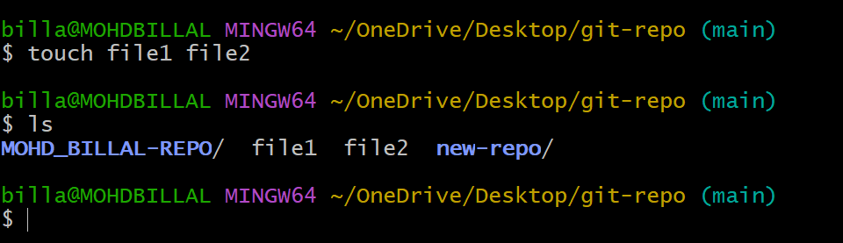

- Commit two files and push to central Repository.
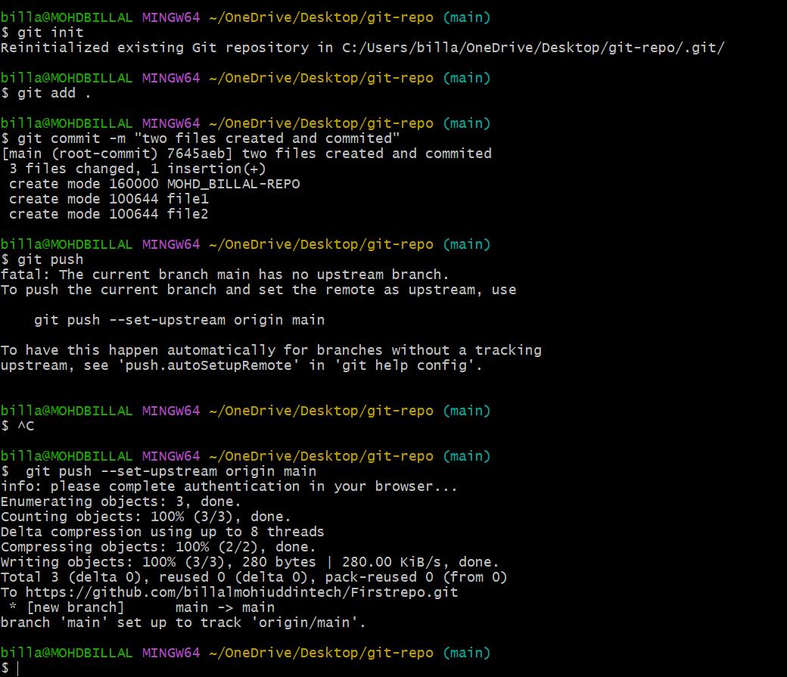
- Create a branch in local and create a sample file and push to central.
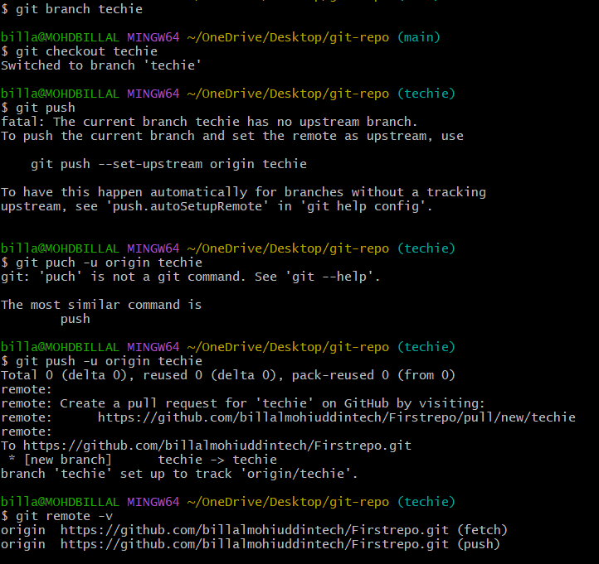

- Create a branch in github and clone that to local.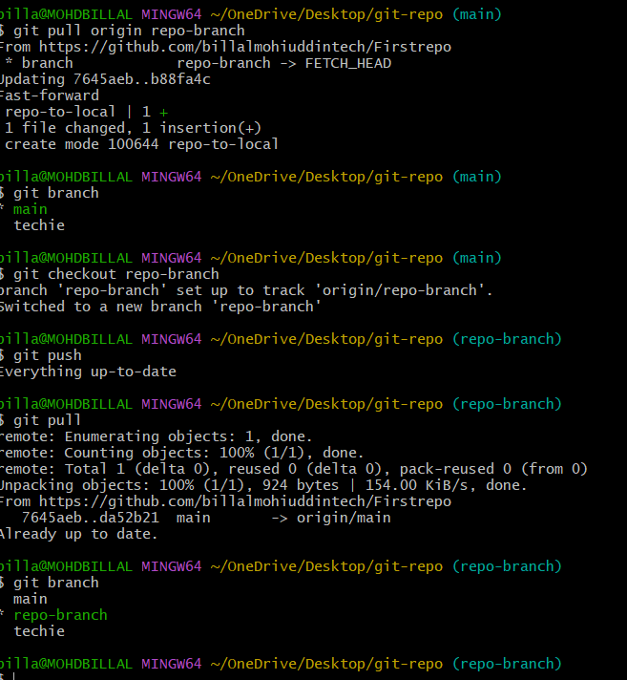

- Merge the created branch with master in git local.
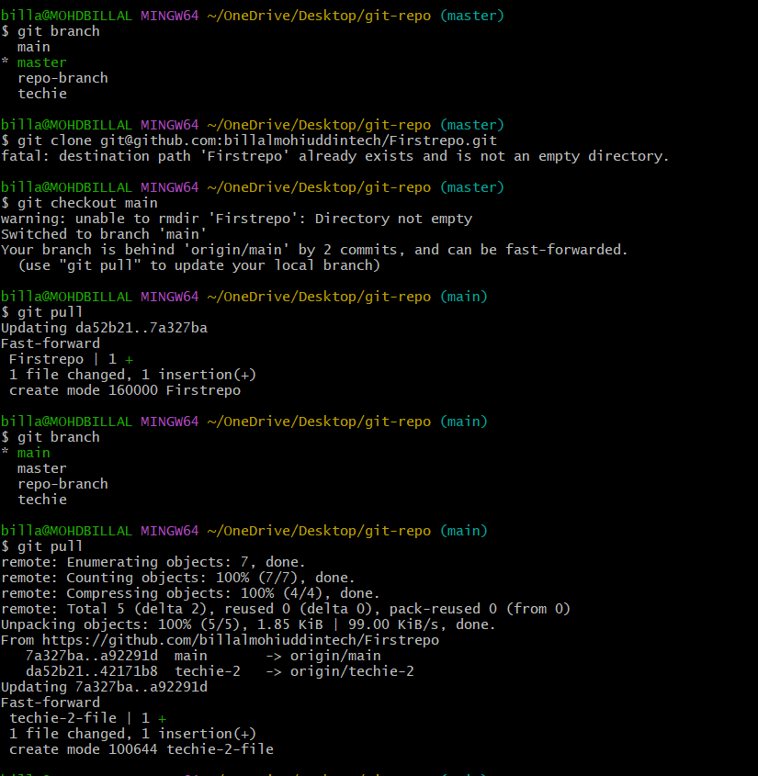

- Merge the created branch with master in github by sending a pull request.
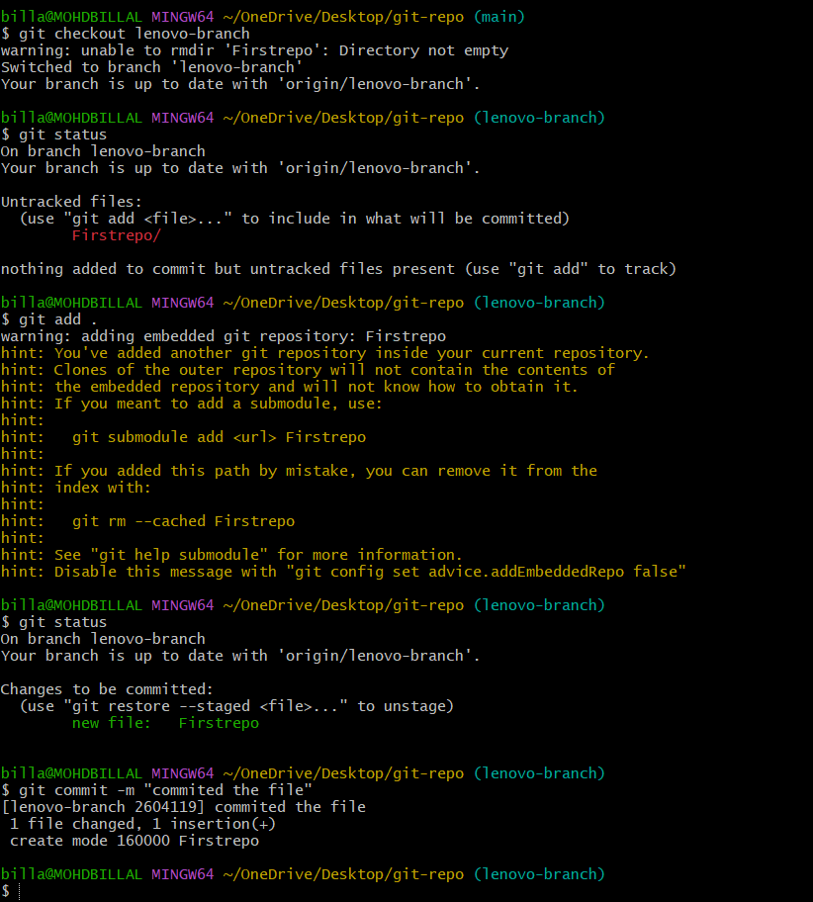
- Create a file in local and send that to branch in github.
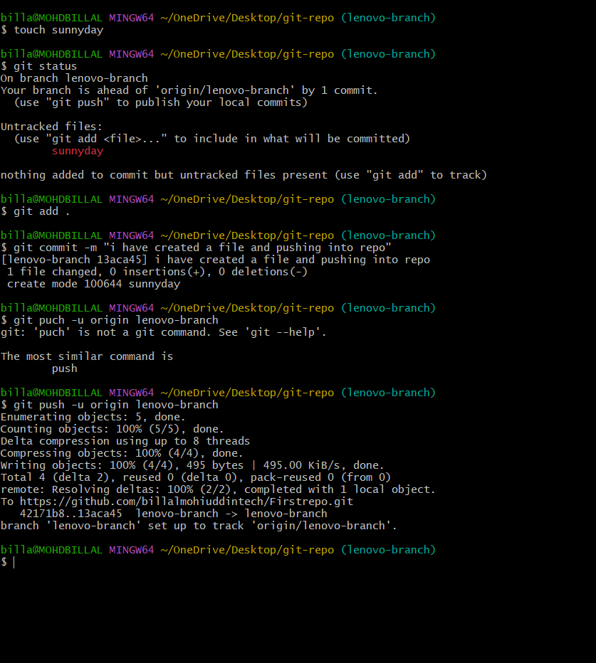

- Clone only a branch from github to local.
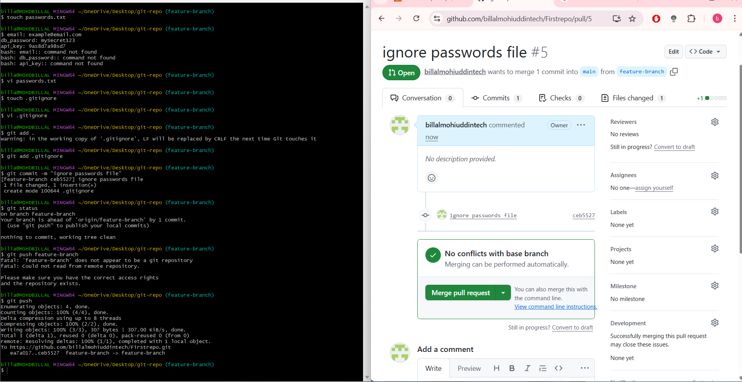

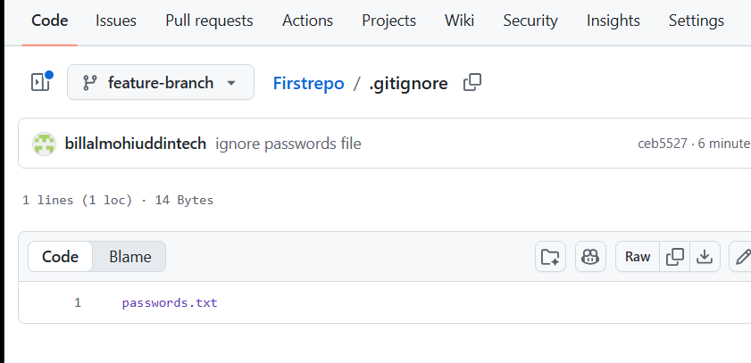
- Create a file with all passwords and make that untrackable with git.
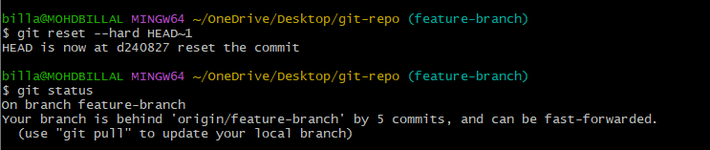

- Make a commit and make that commit reset without savings changes.
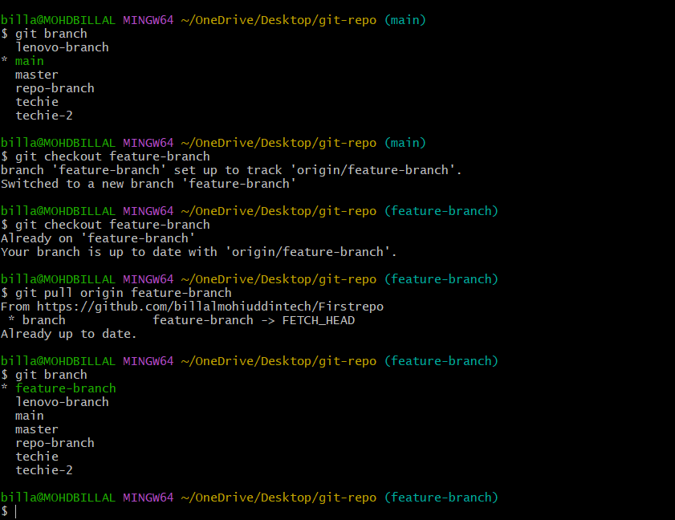

- Revert a commited commit to the older version.

- Push a file to stash without savings the changes and work on another file.
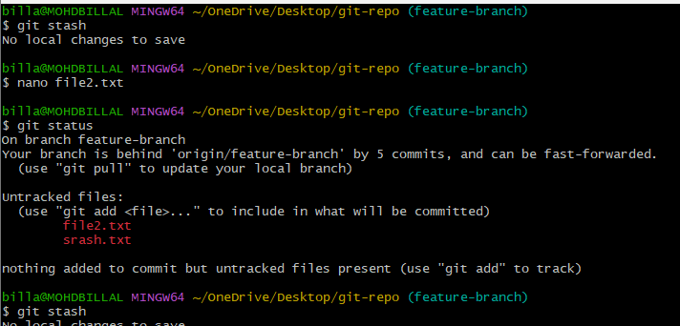
- Undo the stash file and start working on that again.
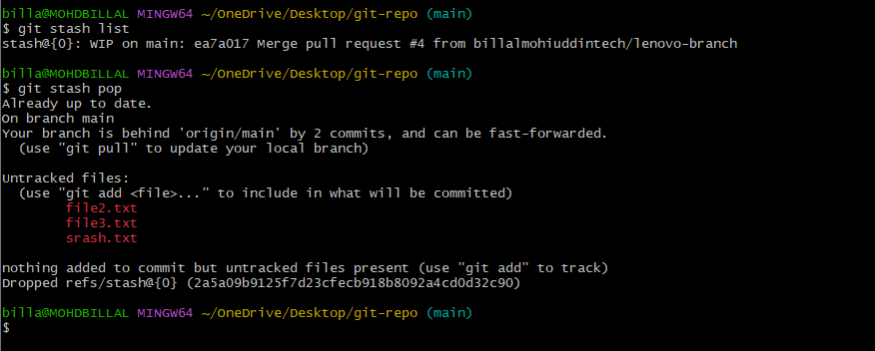
- Generate a ssh-keygen and configure into github.
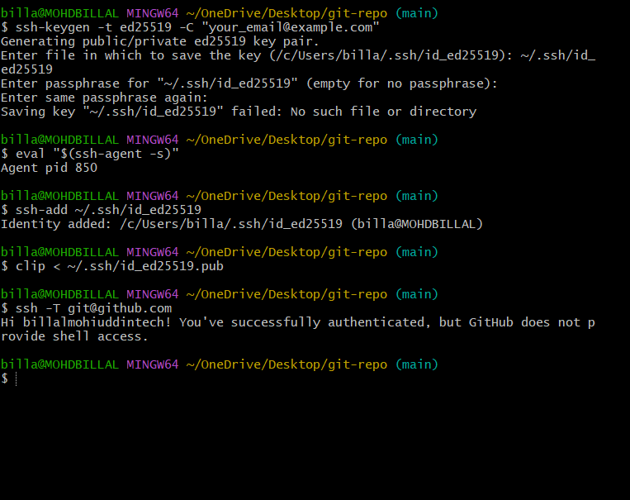

- Configure webhooks to github.
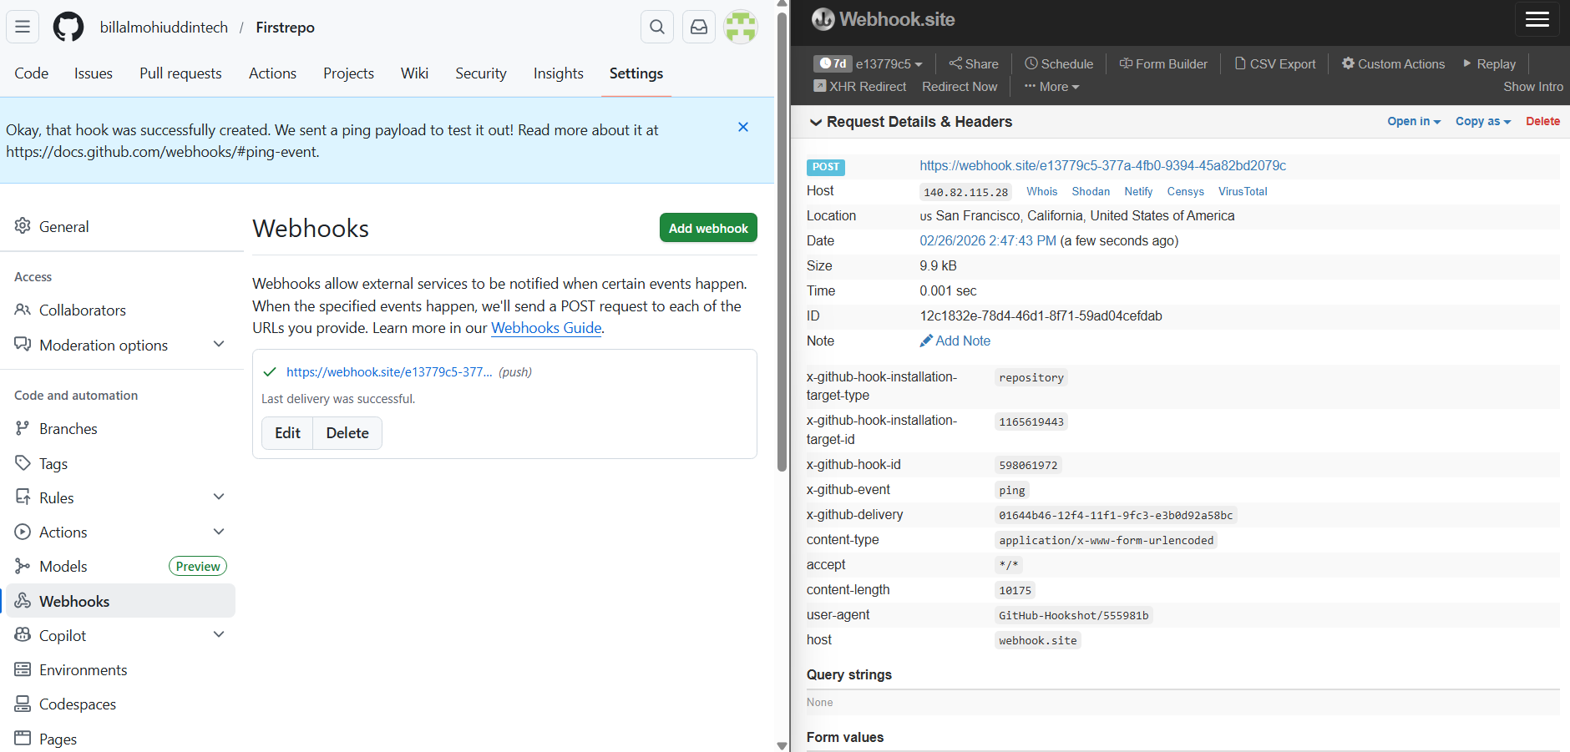

- Basic understanding of .git file.

.git is the brain of Git. It stores everything.
Important files/folders:

.git/
├── HEAD → current branch
├── config → repo configuration
├── objects/ → commits, trees, blobs
├── refs/ → branches & tags
├── logs/ → commit history logs
├── index → staging area
Key point:
Deleting .git = project is no longer a git repo

- Check all the logs of git.
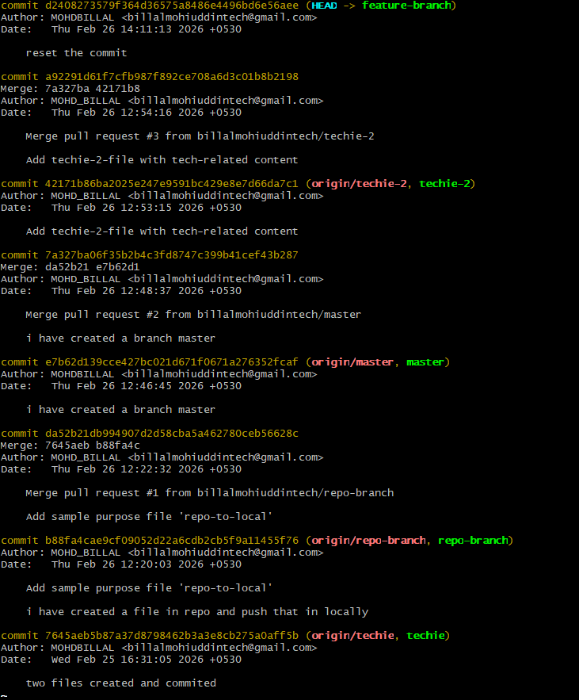

- Rename the commit message.
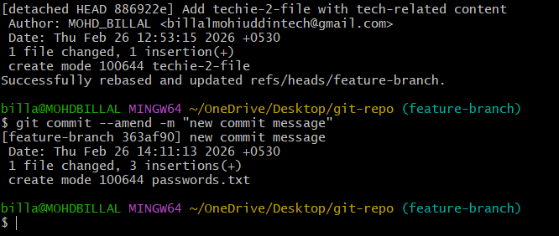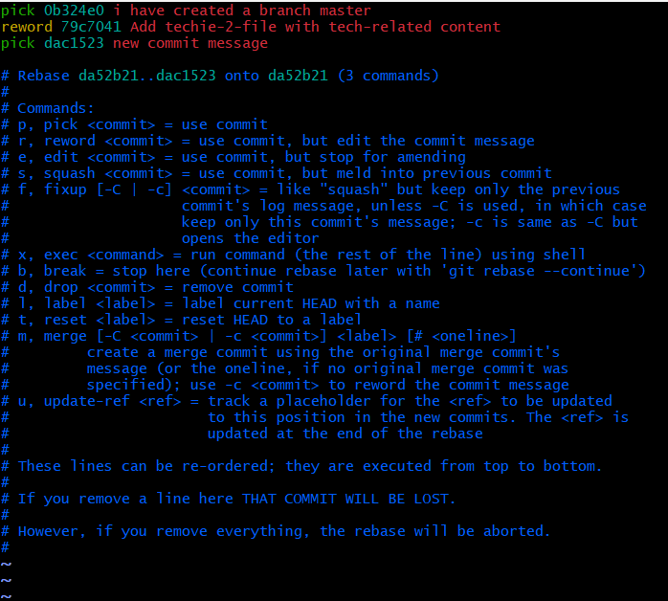

22.Merge multiple commits into single commit.
